Muhlenberg County Public Libraries Online Resources
KYVL Learning Express
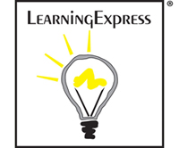
Learning Express has a wide selection of educational opportunities for all ages. Whatever your goal, Learning Express Library’s resources will help you succeed. Each of our Learning Centers offers the practice tests, exercises, skill-building courses, eBooks, and information you need to achieve the results you want—at school, at work, or in life. Looking to land a job? You’ll find an entire Learning Center dedicated to helping you get the one that’s right for you.
College Admissions Test Prep
- Prepare for Your ACT® Test
- Prepare for Your SAT® Test
- Prepare for Your PSAT/NMSQT® Test
- Prepare for Your AP® Exam
- Prepare for the TOEFL iBT® and IELTS™ Tests
- College Admissions Essay Writing

Computer Skills Center
- Get Started with Your Computer
- Get Started with the Internet
- Popular Software Tools
- Learn Computer Graphics and Illustration
- Understanding Your Operating System

Adult Core Skills
- Build Your Math Skills
- Become a Better Reader
- Improve Your Writing, Speaking, and Grammar
- Become a U.S. Citizen

School Center for Elementary, Middle, and High School
- Elementary School
- Mathematics Skills Improvement
  - Geometry Practice
  - Measurement & Data Practice
  - Number & Operations Practice
  - Operations & Algebraic Thinking Practice
English Language Arts Skills Improvement
  - Informational Reading Practice
  - Literature Reading Practice
  - Writing & Language Practice

Middle School
- Mathematics Skills Improvement
  - Expressions & Equations Practice
  - Functions Practice
  - Geometry Practice
  - Number System Practice
  - Ratios & Proportional Relationships Practice
  - Statistics & Probability Practice
  - Tutorials
  - eBooks
- English Language Arts Skills Improvement
  - Informational Reading Practice
  - Literature Reading Practice
  - Writing & Language Practice
  - Tutorials
  - eBooks
- Social Studies Skills Improvement
  - American History Practice
  - Geography Practice
- High School Entrance Exams Preparation
  - COOP Preparation
  - HSPT Preparation
  - SHSAT Preparation
  - SSAT Preparation
  - ISEE® Preparation

High School
- Mathematics Skills Improvement
  - Algebra Practices
  - Functions Practices
  - Geometry Practices
  - Number and Quantity Practices
  - Quantitative Comparison Practice
  - Statistics and Probability Practices
  - Tutorials
  - eBooks
- English Language Arts Skills Improvement
  - Informational Reading Practice
  - Literature Reading Practice
  - Writing & Language Practice
  - Vocabulary and Spelling Skills Practice
  - Word Analogies Practice
  - Synonyms and Antonyms Practice
  - Tutorials
  - eBooks
- Science Skills Improvement
  - Biology Practice
  - Chemistry Practice
  - Earth Science Practice
Social Studies Skills Improvement
  - American History Practice
  - Civics Practice
  - Geography Practice
- Technology Skills Improvement
  - Computing & Information Technology
  - Information Systems
  - Management Information Systems
  - Technical Writing
- Logic and Reasoning Skills Improvement
  - Logic and Reasoning Practice

College Students
- Math Skills Review
- Reading Skills Review
- Grammar and Writing Skills Review
- Science Skills Review
- Prepare for Graduate School Admissions Exams
- Prepare for College Placement Exams
- Prepare for the CLEP® Exams

Ged Prep Center:
- Are You Ready?
- Build Your Basic Skills
- Practice for the GED® Test
- GED® en Español

Career Prep:
- Learn More About a Career
- Job Search and Workplace Skills
- Prepare for the Air Traffic Controller Exam
- Prepare for Allied Health and Social Worker Exams
- Prepare for Civil Service Exams
- Prepare for Commercial Driver's License (CDL) Exams
- Prepare for Cosmetology Exams
- Prepare for Culinary Arts Exams
- Prepare for Electrician and Plumbing Exams
- Prepare for Emergency Medical Services and Firefighting Exams
- Prepare for Law Enforcement Exams
- Prepare for Military Exams
- Prepare for Nursing Exams
- Prepare for Real Estate Exams
- Prepare for Teaching Exams
- Prepare for the WorkKeys® Assessments and the TOEIC®

Job and Career Accelerator
- Build Resumes and Job Letters
- Find a Career Match
- Explore Occupations
- Search for Jobs and Internships
- Prepare for an Interview
- Career eBooks Library
- Discover Schools and Scholarships

Many other resources are available within Learning Express for all ages.
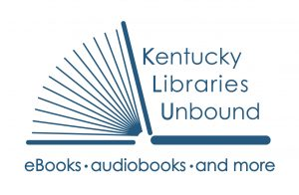
At Kentucky Libraries Unbound, you can download eBooks, Audiobooks, Videos and Music.

Learn a new language for free with your library card!
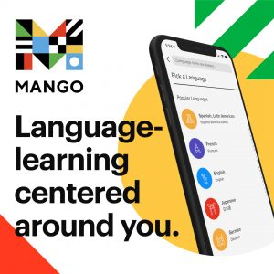
Heritage Quest is an online history and genealogy database. Search censuses, books, war records, and more.

Consumer Reports provides ratings on cars, appliances, electronics, and more! Check out reviews before you buy!

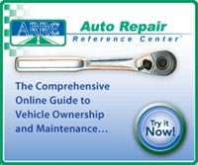
Auto Repair Reference Center is your comprehensive online guide to vehicle ownership and maintenance.

Kentucky Virtual Library (KVL) is dedicated to supplying all Kentuckians with a comprehensive and dynamic collection of information resources. We strive for equitable access to quality library and information resources for all Kentuckians.

